Chicken and Mushroom Marsala
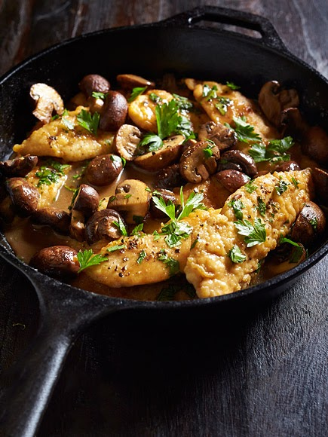
Prep time: 15 Minutes
Cook time: 20 Minutes

Serves: 4

Ingredients
- 1 lb. chicken breast tenders
- ½ cup all-purpose flour
- 1 ½ tsp. coarse salt, divided
- ¾ tsp. freshly ground black pepper, divided
- ¼ cup canola oil
- 8 oz. cremini mushrooms, stemmed and cut into 1-inch pieces
- ½ cup dry Marsala wine
- ½ cup chicken stock
- 2 tbsp. unsalted butter
- ¼ cup chopped flat-leaf parsley or chives, plus more for garnish

Directions
- Place chicken on a cutting board in a single layer, and cover with plastic wrap. Lightly pound using the flat end of a meat mallet until tenderloins are ¼-in. thick.
- Stir together flour, ½ tsp. salt and ½ tsp. pepper in a wide, shallow bowl.
- Heat oil in a large skillet over medium heat until shimmering.
- Dip chicken pieces in the flour mixture, turning to coat both sides.
- Shake off excess flour and place in the heated skillet.
- Cook 3 minutes on each side, or until golden and cooked through. Remove from the skillet and keep warm.
- Add mushrooms to skillet and sauté over medium-high heat for 5 minutes, until water has evaporated and mushrooms are browned. Season with remaining 1 tsp. salt and ¼ tsp. pepper.
- Add wine, and bring to a boil over medium heat for 1½ minutes, or until reduced by half.
- Add chicken stock, and simmer for 5 minutes, until sauce reduces slightly. Stir in butter.
- Return chicken to pan, and simmer gently for 1 minute to heat through. Garnish with parsley or chives before serving.

